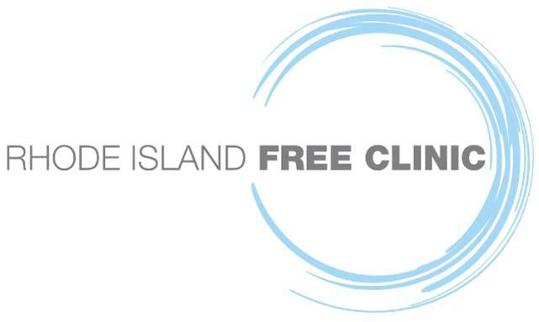

Highlighting the AmeriCorps VISTA Program at RIFC

PROVIDENCE, RI (November 22, 2022) –

The AmeriCorps VISTA program allows its members to support an organization that is pushing for sustainable change in areas that effect poverty, including education, public health, climate, access to benefits, and more. The full time volunteers commit to one year of service taking on roles including fundraising, grant writing, research, volunteer recruitment, and capacity building that will allow them to gain professional experience and opportunities.

At the Rhode Island Free Clinic, the VISTA program is a strong aspect of our family. The Rhode Island Free Clinic has collaborated with AmeriCorps VISTA since 2003, mobilizing over 80 VISTA Volunteers to help build Clinic capacity and aid in patient care, including outreach initiatives and data analysis used to improve patient health outcomes. Our current VISTA team includes a Non-Provider Patient and Volunteers Services VISTA, a Provider Patient and Volunteer Services VISTA, a Clinical Operations VISTA, and a Grants and Program Development VISTA. Serving on the front lines of public health, our VISTA Members have been instrumental in RIFC’s operations to provide critical health services for our patients, including COVID-19 testing and vaccination efforts.

Hear about Elsa Batten, Isabel Eggleston, Markisee Martin, and Meredith Nailor’s experiences with the AmeriCorps VISTA program and the Rhode Island Free Clinic here.

Our VISTA program’s strength and commitment would not be possible without the hard work and dedication of Marvin Ronning. He was a guiding force for our VISTAs and continuously shared his passion for the clinic and providing care for patients. He will be missed by all. Hear Marvin Ronning share his experience with the AmeriCorps VISTA program here.

