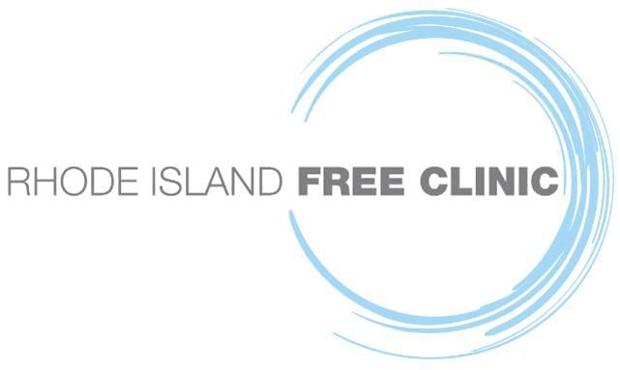

For Immediate Release
March 7, 2022

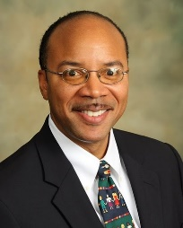

Rhode Island Free Clinic Announces New CEO
Dr. Forrest Daniels

Rhode Island Free Clinic Board of Directors announced the selection of Forrest A. Daniels, MPA, DSc, FACHE as its new Chief Executive Officer. “We’re thrilled to have Dr. Daniels join us to lead our high performing Clinic Team,” said William Fitzgerald, Board President. Dr. Daniels succeeds Dr. Marie Ghazal who is retiring on March 31st after twelve years of service and growth for the Clinic.

A former resident of Amherst, MA, and a graduate of Howard University and Indiana University, Dr. Daniels earned his Doctor of Science in Healthcare Leadership from The University of Alabama-Birmingham. He is board certified in healthcare management, a Fellow of the American College of Healthcare Executives and a recipient of the ACHE Chairman’s Service Award for his contribution to healthcare management excellence through his volunteer service to the profession and College.

Dr. Daniels returns to New England from the mid-Atlantic where he served with the Maryland Department of Health since 2019, most recently as CEO of the Eastern Shore Hospital Center. Dr. Daniels’ career has focused on serving the nation’s most vulnerable in senior management positions at hospitals, federally qualified health centers, and community organizations, including the District of Columbia Department of Health, and the D.C. Department of Corrections. “I look forward to moving to Rhode Island to work with Free Clinic volunteers, community partners, and supporters to advance the Clinic’s mission to ensure vital health care for adults in need from throughout Rhode Island,” said Dr. Daniels.

About Rhode Island Free Clinic
Founded in 1999, the Rhode Island Free Clinic provides a comprehensive Medical Home to uninsured, low-income Rhode Island adults, and serves as an educational training site for aspiring health care professionals through partnerships with Rhode Island’s leading Academic Partners. The Clinic annually mobilizes over 600 volunteers and community partners to provide care and training. Care includes primary care, dental, behavioral health, specialty care, physical and occupational therapy, wellness education, medicine, and more -- all free to vulnerable Rhode Islanders.
Learn more by visiting www.rifreeclinic.org .

For information about the Clinic, please contact Marvin Ronning at mronning@rifreeclinic.org or 401-274-6347, ext. 322.

-###

