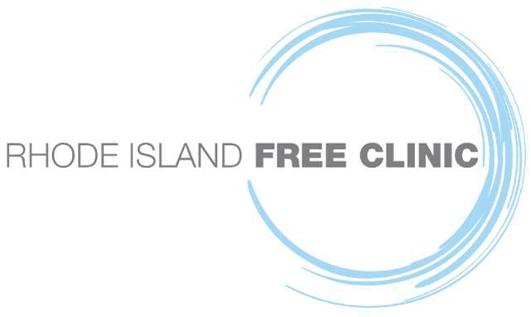
For Immediate Release

Rhode Island Free Clinic Announces Officers and New Board Members for 2022

PROVIDENCE, RI (January 7, 2022) –

“Twenty-two months from the start of the pandemic, our state’s most vulnerable communities – uninsured, underserved, majority Spanish speaking – continue to feel its impact,” said Marie Ghazal, DNP, RN, CEO of the Rhode Island Free Clinic. “In the past year, the Clinic saw a 218 percent increase in adults needing care. On the front lines of the COVID-19 pandemic, the Clinic served over 5,600 vulnerable RI adults, and provided over 10,000 COVID-19 Tests and Vaccinations to keep our community safe and well. Access to vital care for our state’s most vulnerable communities is more critical now than ever. The Clinic relies on donations and volunteers to care for at-risk adults from across Rhode Island.”

“We are pleased to welcome these outstanding community leaders to our high-performing team,” said Clinic Board President, William Fitzgerald, Vice President, Amica Mutual Insurance Company. Board Officers include, Carrie Bridges Feliz, Vice President; George Greer, Treasurer; Jeffrey Chase Lubitz, Secretary; and Mark Gim, President Emeritus.

New Members to the Board of Directors are Diana Ducharme, Esq., Cervenka Green & Ducharme, LLC, Brendan Kane, Principal, Peregrine Property Management, and Marina Rodriguez, MD.

Diana M. Ducharme is a Member of Cervenka Green & Ducharme LLC, Rhode Island’s first women-owned business law firm. She has over 25 years of commercial real estate development and finance law experience at Providence-based regional business law firms.

Brendan Kane is owner of Peregrine Property Management, Rumford, RI. He leads business strategy, employee development and overall growth and direction for the company’s real estate including: mills, industrial, retail, residential, office, mixed use, and institutional.

Marina Rodriguez is a Board-Certified Internal Medicine Physician and Clinical Assistant Professor, Brown. She has been a longstanding volunteer at the Clinic and previously practiced at Brown Medicine.

For information about the Clinic, please contact Marvin Ronning at mronning@rifreeclinic.org or 401-274-6347, ext. 322.

About Rhode Island Free Clinic
Founded in 1999, the Rhode Island Free Clinic provides a comprehensive Medical Home to uninsured, low-income Rhode Island adults, and serves as an educational training site for aspiring health care professionals through partnerships with Rhode Island’s leading Academic Partners. Care includes primary care, dental, behavioral health, specialty care, physical and occupational therapy, wellness education, medicine, and more -- all free to vulnerable Rhode Islanders. Learn more by visiting www.rifreeclinic.org

-###

